2019

Summer Provance, Nick Zimmerman, Manuel Kent, Daniel Moore

FI-CON

12/9/2019

Production Planning Final Report

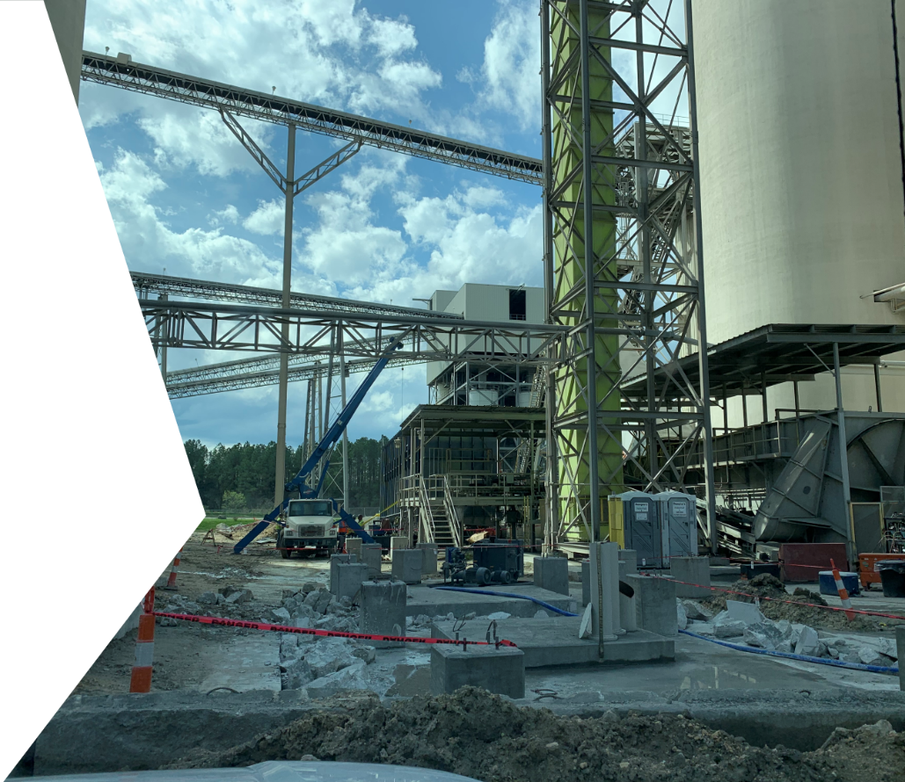

Table of Conte­nts

Abstract 2

Introduction 2

Assumptions 3

Design and Methods 5

Proposed Solutions 6

Additional Factors 12

Environmental and Societal Factors 13

Previous Work 14

Future Work 15

Discussions and Conclusions 16

References 17

# Abstract

Florida Industrial Construction (FI-CON) is a custom steel fabrication and installation company located in Live Oak, Florida. The company has asked our senior design team to create a decision support system (DSS) to aid in their production planning process. This DSS would help them track man hours, estimate job completion dates, give more accurate customer price quotes, track productivity of workers, and visualize the locations of jobs throughout the shop.

Our team started our research by interviewing key members at FI-CON, and quickly realized there was a lack of data and a lack of a system to collect that data. Given the software infrastructure in place, we decided to pivot our focus to help the company with their data collection. We believe this will be the foundation to a future tool that could provide the needed data analysis and visualization to managers, workers, and customers alike.

# Introduction

Taylor Industrial Construction was established in 1991 and provided steel fabrication and installation services to customers in the Southeastern region of the United States. Miguel Senior has recently purchased Taylor Industrial Construction and renamed it Florida Industrial Construction (FI-CON). Upon purchasing the company, Mr. Senior had goals of standardizing processes, improving quality, and improving on-time delivery.

To help Mr. Senior in his goal of standardizing processes, he has tasked our senior design group with creating a production planning decision support system for the fabrication shop. Two of the biggest hurdles to standardizing and understanding where projects are in the shop floor are the lack of data and the fact that most orders are entirely unique.

Currently the shop floor workers are supposed to write down what work they accomplished each day on a paper form at the end of the day. This rudimentary system results in inflation of hours, nonspecific job tasks, and minimum transparency and accountability. The current state of this process makes it difficult for the shop supervisor to gather the total number of manhours spent on each project. This in turn makes it difficult to predict exactly how many hours should be spent in total on each project, complicating the process of quoting labor costs and predicting completion dates. Our team’s main goal is to create a system for workers to track how many hours were spent on each part of a job and how many hours it took in each workstation. We believe this data will provide a far better base for the estimation of labor costs and completion dates, allow management to hold workers more accountable, and allow customers to have better visibility into the current progress of their orders.

# Assumptions

Throughout our project, we operated under the following assumptions:

* FI-CON does not possess the financial and human resource capability to implement a professional inventory and productivity tracking system.
  + For this reason, we will dedicate ourselves to creating a custom solution.
  + If FI-CON decides in the future to install a cloud-server based professional solution we will make sure to provide a document of potential alternatives, costs and implementation procedures.
* The information provided by employees on software used, data tracked, and daily duties is accurate to the best of their knowledge.
* FI-CON personnel have limited understanding of Excel and VBA software.
  + For this reason, we will aim to design the most user friendly and human error proof tool in order to prevent data collection mistakes.
* The information provided regarding the current issues by the shop operators and the shop managers is correct and it reflects the current situation in the shop.
* The job sequence, time sheets, operator, assembly and subassembly lists and examples provided are accurate and essential to the data collection process.
  + We will use this information to create the structure and functionality of our data gathering tool, in order to collect the most important information while providing the best user experience.
* The shop managers and senior designer will create and maintain the list of current projects in the pipeline so that the tool can be effectively used.
* The shipping of material to and from FI-CON will not be included in man-hours when calculating the project cost.
  + We believe this is a reasonable assumption because FI-CON has told us that there is not a large variation in the labor cost of moving material between projects and they are accounted in transportation and material costs.
  + FI-CON currently orders materials from an established list of suppliers and their clients are regional, therefore the shipping times of finished products will not deviate significantly.

# Design and Methods

Our main focus in designing our system was making it as user friendly as possible for those that will be using it every day. A main concern that we saw early on in our plant visits was that the use of our system by operators on the shop floor would drastically affect their productivity and we wanted to minimize this as much as possible. We designed it so that it could be used by operators in just seconds and they did not need to spend minutes at the computer trying to figure out how it works.

The only real “data” we used in designing our system, other than actual project sheets that were given to us by FI-CON, was feedback from employees on the shop floor and from management. It was crucial for us to use this feedback in our design because the operators themselves are the ones that know what will and won’t work when it comes to implementing the solution. We collected this feedback through various trips to FI-CON’s Live Oak facility where we spoke with the operators and management and showed them what we had been designing, as well as phone and video calls with FI-CON employees and with Mr. Senior.

# Proposed Solutions

**Data Collection DSS:**

The solution that we decided to implement at FI-CON is a data collection system that will aid them in tracking important project data. Currently, FI-CON tracks work data from the shop floor primarily by hand and on paper. Our system will allow FI-CON to digitize this information and use the data to aid their production planning later on. The data that this system will track includes but is not limited to: total man hours spent on each project, items completed from each project, which workers worked on which items, and findings from quality control inspections. We will now explain the functionality of the system that we created.

**Start Page:**

When the DSS is opened the user will be presented with the Start page, as shown in Figure 1.

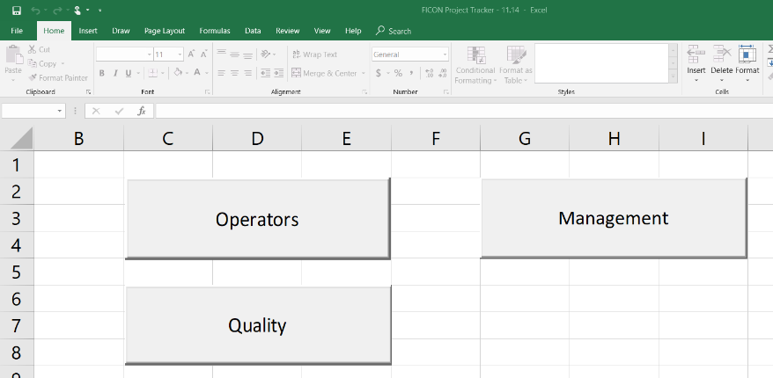

Figure

From here the user can select one of the three main branches of the system: Management, Operators, or Quality.

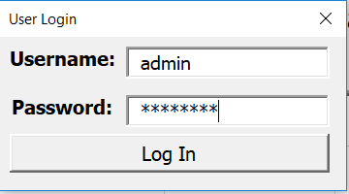**Management:**

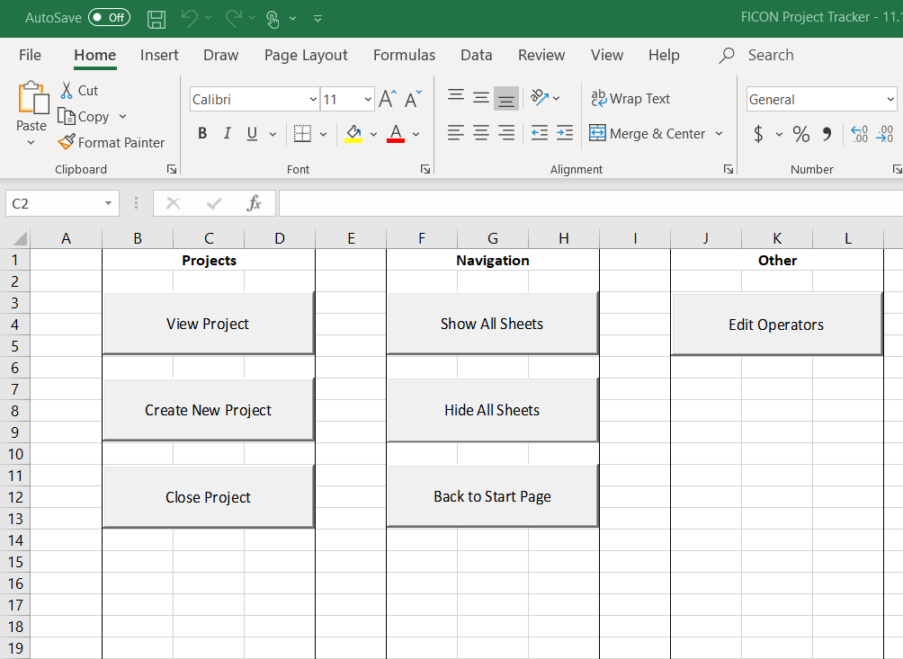For security reasons, management will be asked to login into the system before continuing, as shown in Figure 2.

Figure

After logging in, the user will be guided to the Control Panel, shown in Figure 3. From here the user can access all management functions, including viewing projects, creating new projects, closing projects, navigation, and editing operator data.

Figure

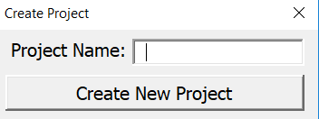

Figure

Creating a new project is a simple as entering a project name into the form shown in Figure 4. This will bring the user to a new project sheet, shown in Figure 5, where they can enter project information by copying and pasting from the “Take-Off” sheets that FI-CON already creates for each project.

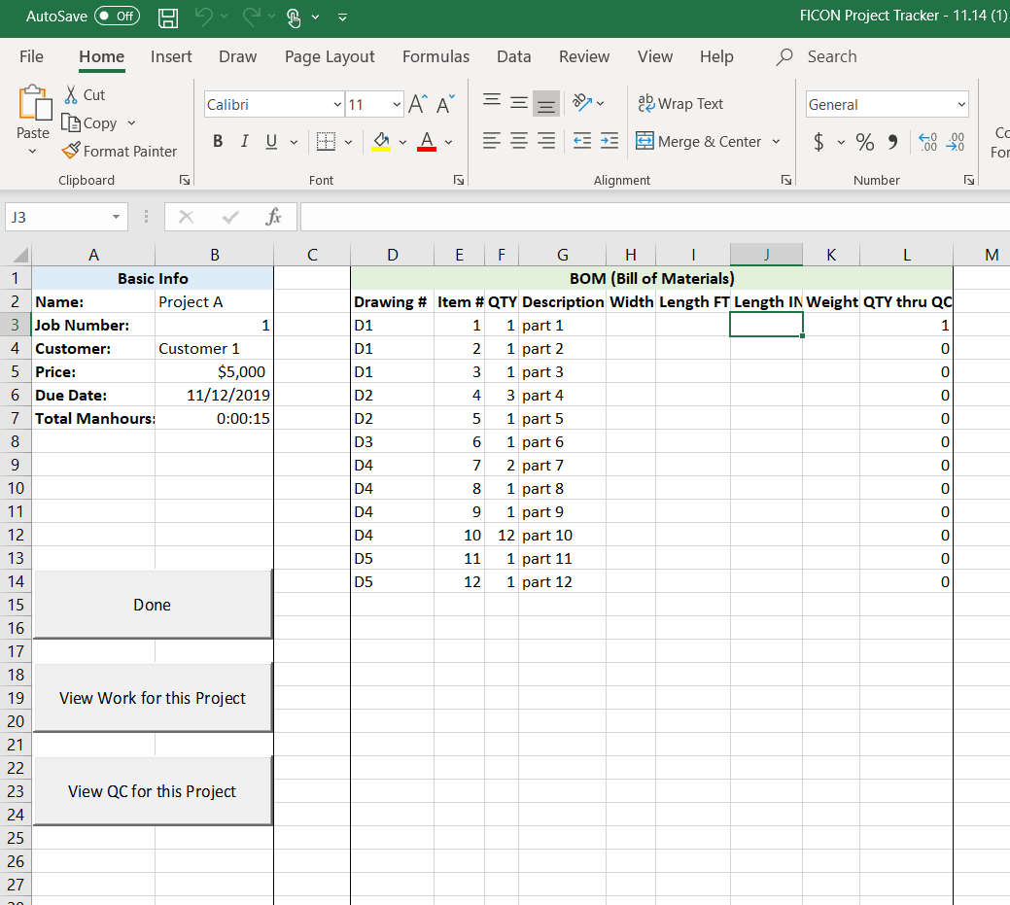

Figure

From this page, the user can also enter basic information on the project, such as the job number, customer, price, due date, and bid manhours. The “Done” button will return the user to the control panel, while the “View Work for this Project” and “View QC for this Project” buttons will show the user the data on work completed and quality control, respectively.

**Operators:**

We designed this system to be as user-friendly for the operators as possible, as they will be the ones interacting with it the most. When an operator selects the “Operators” button on the start page, they will input their name, the project they are working on, the drawing number, the item number, and the process they are working, and their start time will be recorded. When they finish working, they will again select their name, and then be asked to input the quantity of the item they worked on, and click “Stop Job”. This will record the time that operator stopped and the quantity worked.

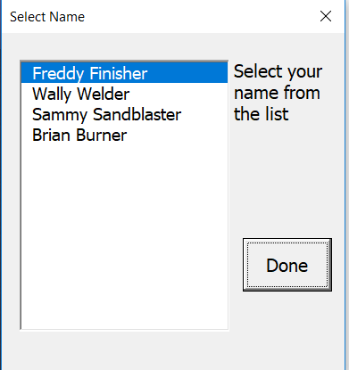 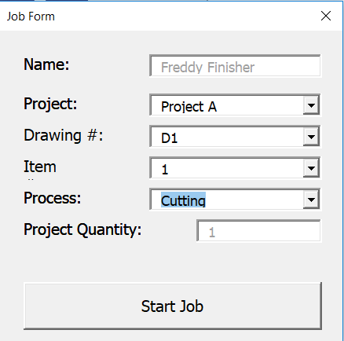 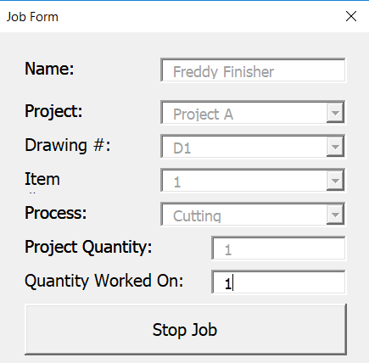

Of course, it is possible that users may forget to click stop on job, so with this in mind we have included and error-checking feature. When an operator selects their name, if their clock has already been running for more than 8 hours, then the system will assume that they forgot to click stop and they will be asked to manually input the time that they stopped.

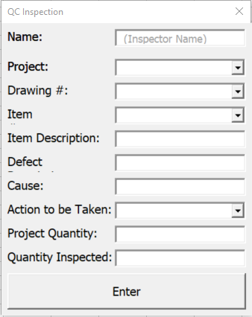**Quality Control:**

A previous Senior Design Team created a Quality Control Form that the quality inspector uses to keep record of the shop’s Quality Inspections. We added a branch to our system to allow the quality inspector to complete this form digitally, shown in Figure 6, so this data can be tracked as well. This form does not require the user to select their name because FI-CON currently has only one quality control inspector.

Figure

**Production Planning DSS:**

The original solution we intended to implement is a decision support system (DSS) for production planning built from scratch through VBA in Excel. One academic paper [5] sited a production planning DSS to offer management a guide to select alternatives and find problems in their production planning. The paper goes onto explain how to use decision variables to see the impact of system performance and create a ranking to the importance of the production system. In order to utilize the methods outlined to create the decision support system, one must have a very exact sequence of a few parts throughout the system. Unfortunately, FI-CON's fabrication shop deals with vastly different projects with different parts and would not be able to utilize a decision support system as the one described in the academic paper. The next paper we read dealt with a DSS for a small job shop manufacturer [6] which seemed more beneficial to FI-CON's small job shop. When studying their shop, they found excessive time to prepare bids, lack of scheduling, lack of inventory control, inaccurate bids, and inadequate cost procedures. These problems are very similar to those that FI-CON faces. Solving these issues requires many keys pieces of information, such as how many manhours are scheduled for the week, how many manhours are used by each job, how many more jobs can fit into the weekly schedule, and which parts need to be ordered. Their end DSS had 4 different tracks: inventory control, bid preparation, production scheduling, and cost accounting for each job. However, this system took over a year to build and implement, placing outside the scope of what we can accomplish this semester. Further, if we wanted to build our own DSS, we would have needed a database to feed into it for it to base decisions off of, and since we did not have this we instead focused on our data collection system. With a solid foundation of data in place, we believe this will be the right solution for FI-CON’s production planning because it will be relatively inexpensive to implement and will be easily tailorable to their needs.

**Standard Time:**

An additional solution we explored was finding an already made software that could be purchased and implemented on the shop floor. We investigated a variety of solutions that targeted small manufacturing shops and logistic centers, including e2b Teknologies [1], Global Shop Solutions [2], Fishbowl Inventory [3], and Standard Time [4]. These solutions needed to be easily implementable, customizable, and come at a reasonable price. FI-CON has already invested in several tools like QuickBooks and Monday.com that have helped them with project management, accounting, and payment distribution. The ideal candidate software would integrate with all of these.

After substantial research we focused on one potential software: Standard Time. Standard time is a company based out of Colorado which offers a data collection solution for small to medium manufacturing shops. It offers a limited free month demo license and has two different license types: a remote desktop or a cloud solution. The cloud platform is offered for $14.59 per user per month, it utilizes a cloud-based server which is maintained by Standard Time IT. An alternative could be a local Windows server based solution for $8.99 a month for each user. The Windows database must be maintained and updated by FI-CON employees. We believe that the cloud based solution would be preferred, firstly because of cost. We can expect between 15 to 20 licenses, so the additional cost per license it not significant. Next, the cloud based solution provides additional IT support capabilities that FI-CON may not possess at the time, and it can be easily integrated with QuickBooks. Standard Time also adapts to different information gathering hardware such as barcodes, scanners, or simple user interfaces.

We decided not to pursue this solution for various reasons. First, this solution would be much harder to tailor towards FI-CON’s needs than a from-scratch DSS would be. This software is built for a generic production shop and in order to make any changes to it, FI-CON would need to work directly with one of Standard Time’s employees. We also felt that with the time we were given to provide a solution, we would not be able to have Standard Time fully implemented in the shop.

# Additional Factors

In addition to those previously stated, there are many factors that have affected the way we did our work. Foremost, we were on a very tight time schedule for this project. The implementation of any of the solutions that we researched was very lengthy (up to a whole year) and this greatly hindered the scope of work that we could accomplish. FI-CON originally wanted us to roll out an entire production planning DSS but seeing that there was no adequate data to feed into this DSS, we reached an agreement that we would instead focus on data collection. The data collection aspect is but a part of what is necessary to have a functioning production planning DSS at FI-CON and with the time we were given was an attainable solution.

Additionally, FI-CON’s location in Live Oak (roughly seventy miles from the University of Florida Gainesville campus) further hindered the amount of work that we could deliver. Every trip we made to collect information at the plant or interview workers had to be planned out thoroughly and was extremely time consuming as it takes over two hours round trip. In order to have a productive visit each time, we had to make sure that all the people that we need to speak to would be there on that day. This was often difficult because FI-CON’s work is so widespread that it often makes employees’ schedules difficult to predict. Even Mr. Senior works off-site typically two or three times a week. This, in combination with our tight time schedule, meant that we could not accomplish as much as we would have liked to at the beginning of the semester and therefore had to restrict our scope.

Another complication to our work and our final proposed solution is that currently all of the employees that work in the fabrication shop share a single computer. Mr. Senior expressed to us upon our first visit to the Live Oak plant that he hopes to purchase and implement iPads or some similar tablet on the shop floor. This meant that the solution that we implemented must be one that can be used very quickly and, ideally, on a tablet platform. Employees cannot spend too much time at the computer waiting to input data because it risks a negative impact to their productivity. Further, our system must be easily replicable at multiple workstations and we needed to build it so that in the future, multiple systems could be linked together to store data in a common place.

# Environmental and Societal Factors

With this project we aimed to reduce the environmental impact of FI-CON's shop floor by replacing paper forms with our digital solution. We also expect that our project will help them better track inventory leading to lower waste and material loss. Finally, there could be some negative environmental issues as well, depending on if the shop decides to purchase hardware. Batteries located in tablets, scanners and computers are known to have toxic components and can be very detrimental to the environment if improperly disposed.

Important societal factors to consider are how our solution impacts FI-CON employees’ lives. One positive impact is higher job satisfaction. If the shop is better able to estimate job competition, this will lead to more on-time deliveries, higher customer satisfaction, and overall employee satisfaction. Also, if the team can use their labor hours more efficiently, it could lead to redistribution of labor and promotions or job changes for workers. These changes could be seen positively or negatively depending on the worker. On the other hand, if workers are resistant to change and logging hours, they might feel more pressure in their jobs from management. The worst-case scenario would be the loss of workers’ jobs due to continued refusal to cooperate, which would affect their livelihoods and their families.

# Previous Work

FI-CON was the sponsor for one senior design team before us, who created a Quality Control Manual to be used on the shop floor at the Live Oak plant. Like the challenges we are facing, it was difficult for them to produce such a document because every product that FI-CON works on must go through its own unique order of processes. For this reason, their manual is very broad and covers the processes that all parts go through, but not necessarily in the exact order. Further, this previous team also faced a struggle in collecting relevant data that they could use for their work. With our data collection system, we were able to digitize the form that this team created so FI-CON can more easily track their quality data as well.

# Future Work

In the upcoming semesters our data collection system will hopefully allow senior design teams to have access to the data that they need in order to expand. By the time these future teams begin their projects, the employees at FI-CON should be much more comfortable with recording data without delaying their everyday work. This will allow senior design teams to get to work on their project right away and not have to fight two battles at once.

A future design team could use our work to further visualize the data to the benefit of both FI-CON and its customers. They could implement a KPI dashboard or other visualization through Power BI which would provide even more feedback to FI-CON on how the shop is performing financially. The following are a few simple things that could be calculated with the data that our system will provide: hours worked in each process, total job progress, days late on average​, bottleneck processes, and total rework cost​. This would allow them to better understand where their performance is lacking and would give them more beneficial information to share with customers, which in turn would improve customer satisfaction and bring in more work.

Additionally, one great project would be assisting FI-CON with the acquisition of new computer hardware. We already know that Mr. Senior wants to implement the use of tablets on the shop floor which would require a cloud service or local network server to allow the tablets and computers to interact with one another. We looked briefly for a tablet that FI-CON could use and found a $299 Microsoft Surface Go that can run VBA and would potentially be perfect for use in the shop, as it can be used as either a tablet or a laptop. A future design team could help FI-CON install our solution onto a couple of tablets and modify it so that multiple systems can work at the same time.

On our first visit, many of the employees expressed their concerns with how the shop floor itself is laid out. This would be a straightforward problem for a senior design team to examine and could help FI-CON increase productivity. FI-CON has tried to make projects and material flow from one side of the building to the other, but employees have told us that often work must move throughout the floor in opposite directions, halting productivity.

# Discussions and Conclusions

This semester, our group was approached with the task of creating a production planning DSS for FI-CON that would provide production scheduling, accurate pricing, and the ability to track job status throughout the fabrication shop. At the beginning of the semester we researched how to create a production planning DSS and explored the alternative option of using an already made software for manufacturers. Both solutions share the same problem, that there is currently no data or way to collect data from the shop floor. Currently, manhours per job, job length estimation, and cost calculations are all estimations and not based off concrete data. Our team pivoted our focus to creating a data collection DSS that was implemented this semester and will lay out a solid foundation for developing more projects in the future. Should FI-CON choose to pursue another project, a later Senior Design team will be able to pick up right where we left off and easily develop a solution for production planning or anything else that FI-CON wishes to see.

# References

[1] *e2b Teknologies – e2b Teknologies | Business Software ...* <http://e2btek.com/>.

[2] “From Quote-to-Cash and Everything in Between Simplify Your Manufacturing with Global Shop Solutions ERP Software.” *Global Shop Solutions*, <https://www.globalshopsolutions.com/>.

[3] “The #1 Manufacturing and Inventory Management Software for QuickBooks.” *QuickBooks Inventory Management Software By Fishbowl*, <https://www.fishbowlinventory.com/>.

[4] White, Ray. “Track Employee Time and Work Orders.” *Standard Time Timesheets*, https://stdtime.com/, <https://www.youtube.com/watch?v=c8Yx-3P6BU8>

[5] Tsubone, Hitoshi, et al. “Decision Support System for Production Planning — Concept and Prototype.” *Decision Support Systems*, vol. 13, no. 2, 1995, pp. 207–215., doi:10.1016/0167-9236(93)e0037-e.

[6] Veerakool, Veera, and Madison Daily. “A Decision Support System for Production Planning and Bid Preparation for a Small Job Shop Manufacturer.” *Computers & Industrial Engineering*, vol. 15, no. 1-4, 1988, pp. 162–165., doi:10.1016/0360-8352(88)90079-4.